DAY 5

Task 3

package day51;

import org.openqa.selenium.Alert;

import org.openqa.selenium.By;

import org.openqa.selenium.WebDriver;

import org.openqa.selenium.WebElement;

import org.openqa.selenium.chrome.ChromeDriver;

import org.openqa.selenium.chrome.ChromeOptions;

public class Tools1 {

public static void main(String[] args) {

System.setProperty("webdriver.chrome.driver","C:\\ChromeDriver\\chromedriver.exe");

ChromeOptions co= new ChromeOptions();

co.addArguments("--remote-allow-origins=*");

WebDriver driver= new ChromeDriver(co);

driver.get("https://demo.guru99.com/test/delete_customer.php");

WebElement txt= driver.findElement(By.xpath("/html/body/form/table/tbody/tr[2]/td[2]/input"));

WebElement submit=driver.findElement(By.name("submit"));

txt.sendKeys("401");

submit.click();

Alert alert1=driver.switchTo().alert();

alert1.dismiss();

txt.clear();

txt.sendKeys("402");

submit.click();

Alert alert2= driver.switchTo().alert();

alert2.accept();

Alert alert3=driver.switchTo().alert();

String a= alert3.getText();

alert3.accept();

}

}

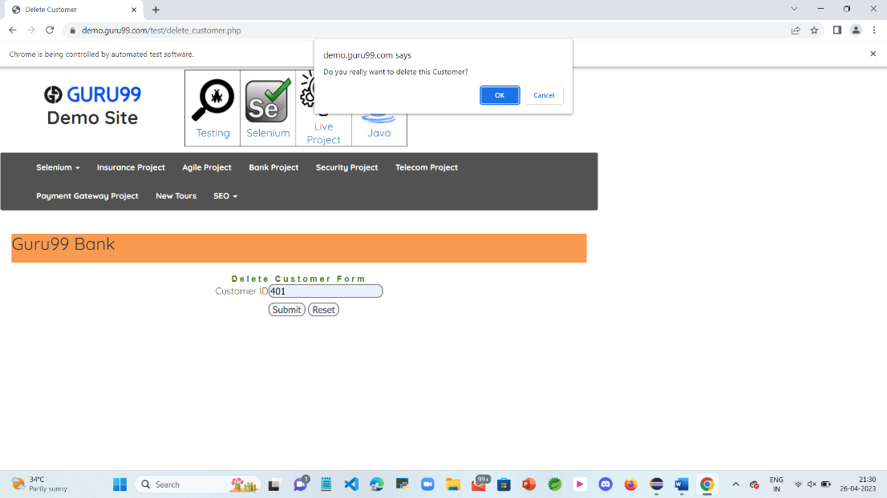

TASK 4

**package** day51;

**import** org.openqa.selenium.By;

**import** org.openqa.selenium.JavascriptExecutor;

**import** org.openqa.selenium.Keys;

**import** org.openqa.selenium.WebDriver;

**import** org.openqa.selenium.WebElement;

**import** org.openqa.selenium.chrome.ChromeDriver;

**import** org.openqa.selenium.chrome.ChromeOptions;

**public** **class** D55 {

**public** **static** **void** main(String[] args) **throws** InterruptedException

{

System.*setProperty*("webdriver.chrome.driver","C:\\ChromeDriver\\chromedriver.exe");

ChromeOptions co= **new** ChromeOptions();

co.addArguments("--remote-allow-origins=*");

WebDriver driver= **new** ChromeDriver(co);

driver.get("https://WWW.abhibus.com/bus-ticket-booking");

WebElement leaving_from = driver.findElement(By.*xpath*("//*[@id=\"source\"]"));

// leaving_from.sendKeys("chennai");

leaving_from.sendKeys("Chennai");

Thread.*sleep*(3000);

leaving_from.sendKeys(Keys.***ENTER***);

WebElement going_to = driver.findElement(By.*xpath*("//*[@id=\"destination\"]"));

// going_to.sendKeys("coimbatore");

going_to.sendKeys("Coimbatore");

Thread.*sleep*(3000);

going_to.sendKeys(Keys.***ENTER***);

WebElement datepicker = driver.findElement(By.*xpath*("//*[@id=\"datepicker1\"]"));

datepicker.click();

JavascriptExecutor js= (JavascriptExecutor) driver;

js.executeScript("arguments[0].setAttribute('value','02-05-2023')",datepicker);

WebElement search_btn = driver.findElement(By.*xpath*("//*[@id=\"seo_search_btn\"]"));

search_btn.click();

}

}

